

**COMP741 – Applications Development**

**Library Management System**

**Diploma in Software Development Level 7**

**Rodrigo Massami Tamura Adati 17018158c@cornell.ac.nz**

**Romeric Heredia [17018054c@cornell.ac.nz](mailto:17018054c@cornell.ac.nz)**

# **Application GUI**

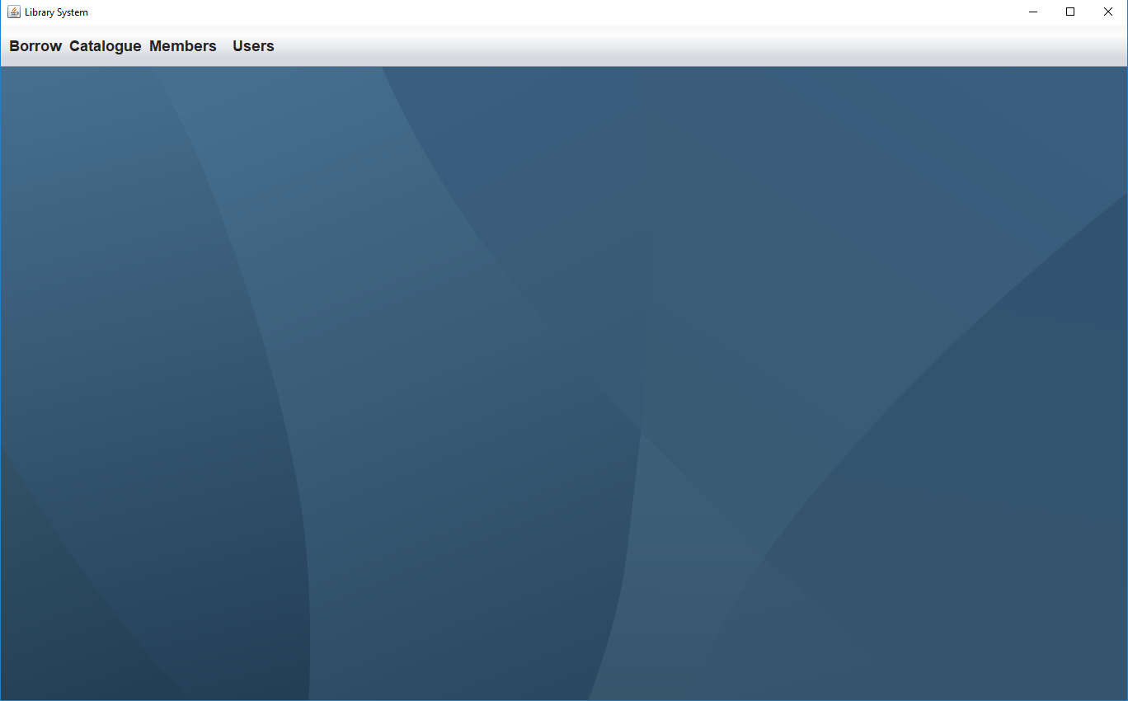

## ***Controls:***

|  |  |
| --- | --- |
| Type | Amount |
| JDesktopPane | 1 |
| JMenu | 4 |
| JMenuItem | 6 |

## ***Events:***

|  |
| --- |
| Borrow Management |
| Book Management |
| DVD Management |
| Change Password |
| User Management |

# **Book Management**

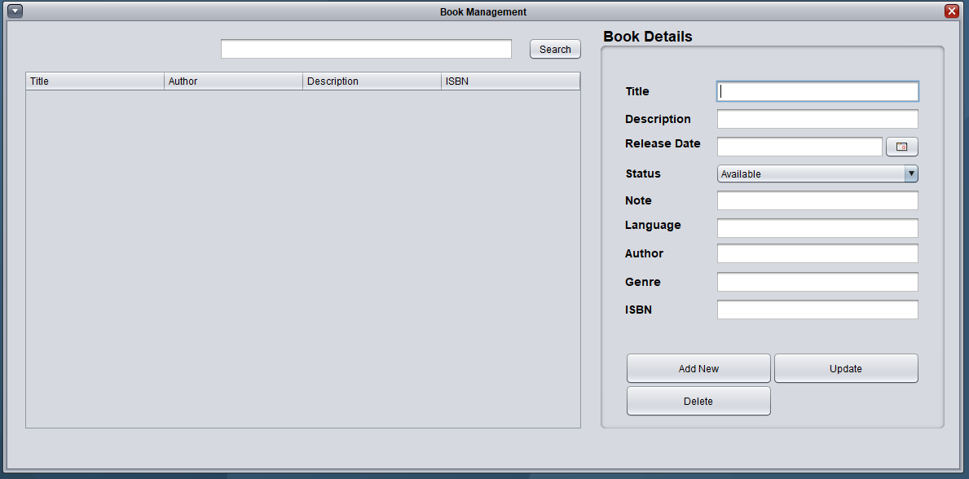

## ***Controls:***

|  |  |
| --- | --- |
| Type | Amount |
| JTextField | 9 |
| JLabel | 8 |
| JButton | 4 |
| JPanel | 2 |
| JComboBox | 1 |
| JTable | 1 |
| JInternalFrame | 1 |

## ***Events:***

|  |
| --- |
| Add Book |
| Update Book |
| Delete Book |
| Search Book |

# **DVD Management**

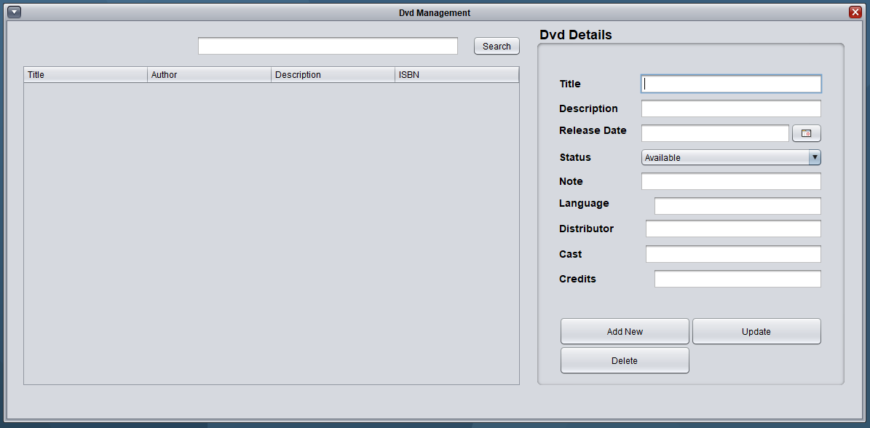

## ***Controls:***

|  |  |
| --- | --- |
| Type | Amount |
| JTextField | 9 |
| JLabel | 8 |
| JButton | 4 |
| JPanel | 2 |
| JComboBox | 1 |
| JTable | 1 |
| JInternalFrame | 1 |

## ***Events:***

|  |
| --- |
| Add DVD |
| Update DVD |
| Delete DVD |
| Search DVD |

# **Member management**

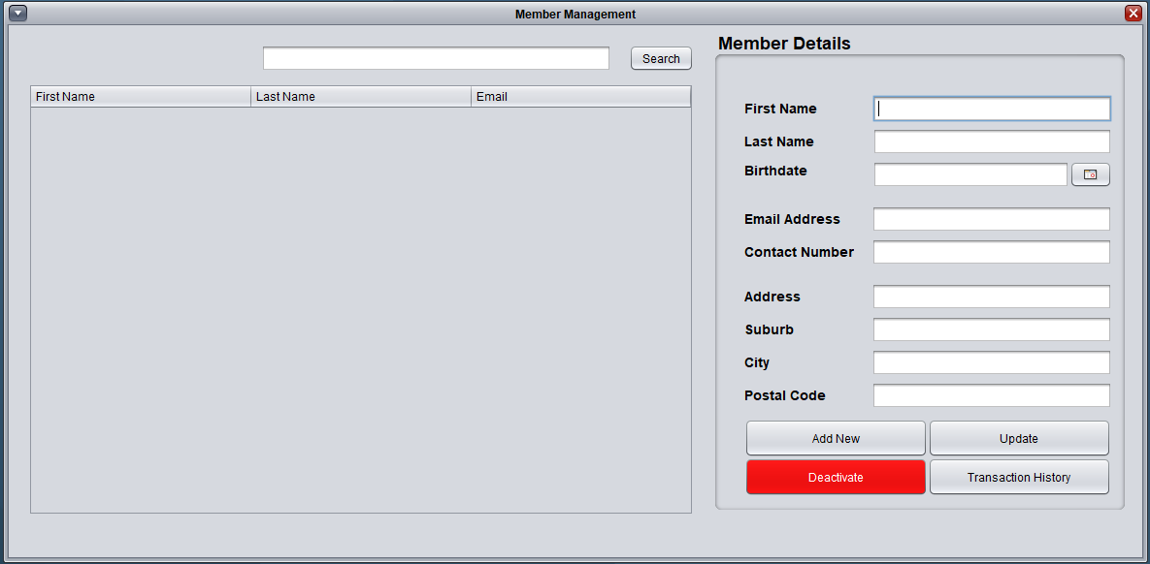

## ***Controls:***

|  |  |
| --- | --- |
| Type | Amount |
| JTextField | 10 |
| JLabel | 9 |
| JButton | 5 |
| JPanel | 2 |
| JComboBox | 1 |
| JTable | 1 |
| JInternalFrame | 1 |

## ***Events:***

|  |
| --- |
| Add Member |
| Update Member |
| Show Transaction History |
| Deactivate Member |
| Search Member |

# **User Management**

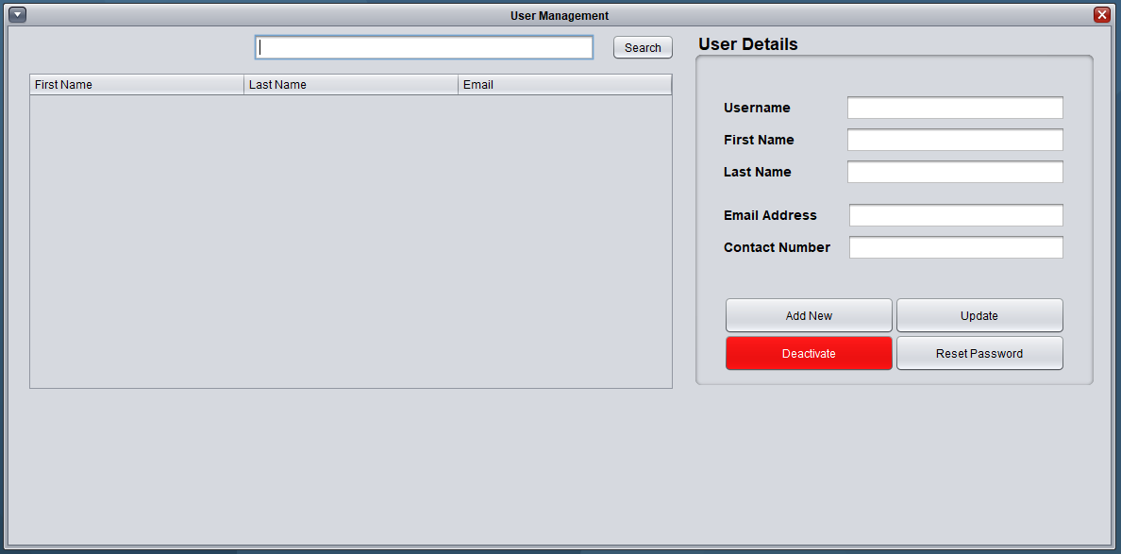

## ***Controls:***

|  |  |
| --- | --- |
| Type | Amount |
| JTextField | 6 |
| JLabel | 5 |
| JButton | 5 |
| JPanel | 2 |
| JTable | 1 |
| JInternalFrame | 1 |

## ***Events:***

|  |
| --- |
| Add User |
| Update User |
| Reset Password |
| Deactivate User |
| Search User |

# **Change Password**

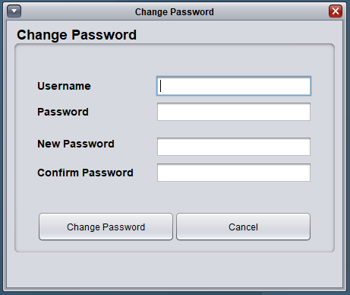

## ***Controls:***

|  |  |
| --- | --- |
| Type | Amount |
| JTextField | 4 |
| JLabel | 4 |
| JButton | 2 |
| JPanel | 1 |

## ***Events:***

|  |
| --- |
| Change Password |
| Cancel |